Logging and Registration system

Registration form was simply created using HTML5 to give form and structure to the project. CSS3 was used to give the form a clean and minimalistic look, so it would be more user-friendly. Next, database was created using MySQL statements and function to create tables and to allow user’s information to be saved within. When database was fully functional, a function for connecting the database to the website’s functionality was written using PHP scripting language (*Fig. 1.1*). Which has consistent connection to the database, ensuring security and information usage. Main function was taking given parameters provided by user, calling the database and storing the information. Finally finished and fined using CSS3 and HTML5 to give professional look and feel to the website. Most of the code has been modularized into several different segments and files to make the whole process more efficient and less time consuming.

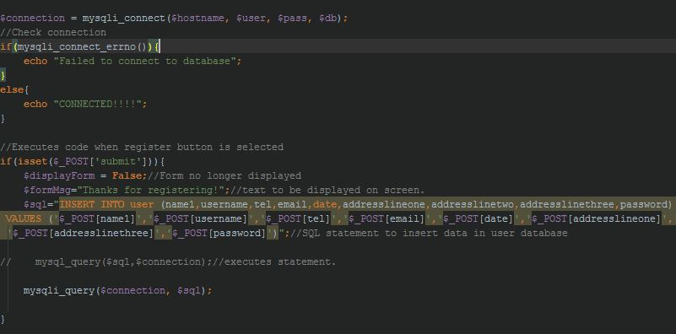

Figure 1.1 – Displaying the connection to the database being created and passing particular parameters to the database using MySQL statements.

Logging form was created using similar manner as the registration form. HTML5 and CSS3 were used to create the structure and the *bones* of the interface. Later several functions have been written using PHP to allow connection to the database and for particular information to be taken out using MySQL commands as seen below in *Fig.1.2*. Finally, it was fined down using CSS3 and jQuery to give precise and neat design for user interaction. jQuery was used to create a modal animation for the form to load up and CSS3 was used to refine the precise look and feel.

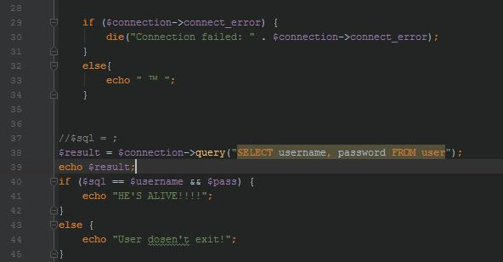

Figure 1.2 – Shows the connection being made to the database using PHP to and selecting user’s password and username from the database to make sure they match together

The website design. After some research done, minimalistic and light coloured design was chosen appropriately. Having in mind the website is aimed at all groups of ages, implicating that the design should be appealing for most of the users. Most of the applications made nowadays, are quite populated with advertisements and a lot of flashy colours to attract as many people as possible. Since this is a different type of website made for helping and providing a service to the users, it has been chosen to show how simply one can create a complete personal computers using different components and installing them together. That was the aim to which should be emphasised throughout the website. Creating comfortable user interface and making navigation and building processes more simple.

This website design does not have any aggressive or resilient colours, which has produced placid and tranquil design. Most of the button and navigation link’s edges have been slightly rounded, CSS3 and jQuery working fully to produce a consistent GUI for users.

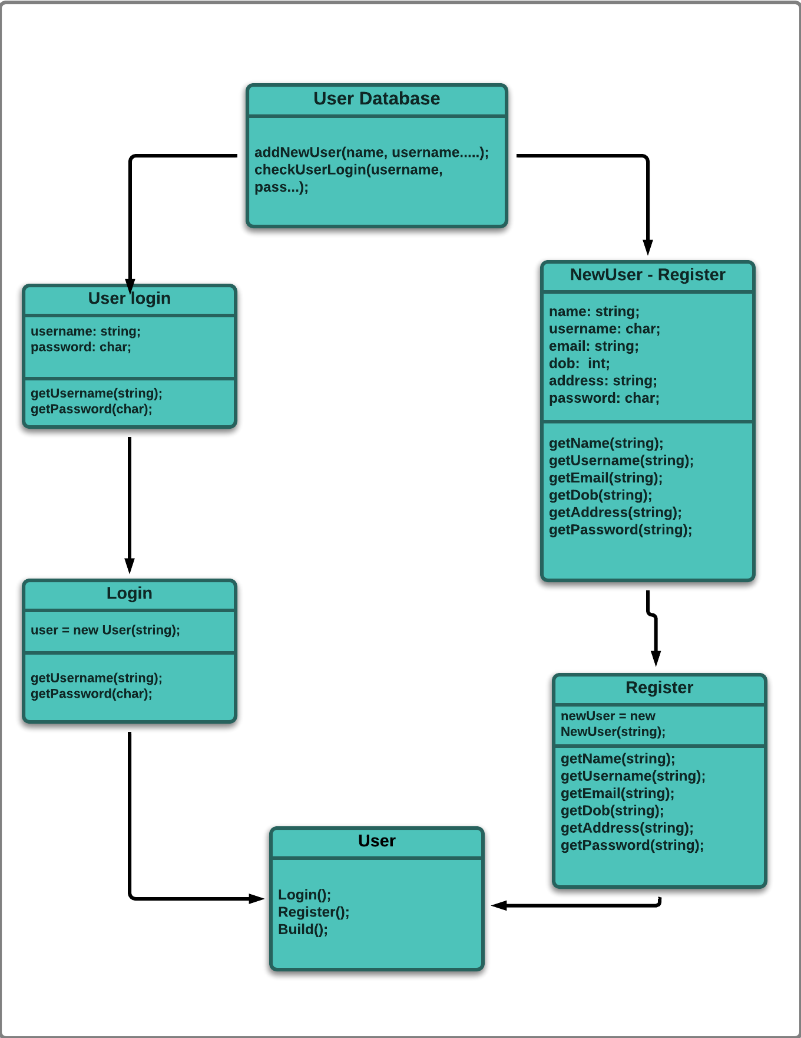

The diagram shows the relationship between user interaction using login and registering systems.